 **Tribhuvan University**

**Faculty of Humanities and Social Sciences**

**A PROJECT REPORT**

**“School Management System”**

**Submitted to**

**Department of Computer Application**

**Bhairahawa Multiple Campus**

*In partial fulfillment of the requirements for the Bachelors in Computer Application*

**SUBMITTED BY:**

Ajay Kumar Agrahari & Mo. Sharif Khan Musalman

TU Registration No: “

Under the Supervision of

Teacher Name:

February 2025

**Tribhuvan university**

**Faculty of Humanities and Social Science**

**Bhairahawa Multiple Campus**

# Supervisor’s recommendation

I hereby recommend that this project prepared under my supervision by Ajay and Sharif entitled “**School Management System”** in partial fulfillment of the requirements for the degree of Bachelor of Computer Application is recommended for the final evaluation.

………………

**SIGNATURE**

**Teaching Assistant**

Bhairahawa Multiple Campus

**Tribhuvan university**

**Faculty of Humanities and Social Science**

**Bhairahawa Multiple Campus**

# LETTER OF APPROVAL

This is to certify that this project prepared by Ajay Kumar Agrahari & Mo. Sharif Khan Musalman entitled “**School Management System**” in partial fulfillment of the requirements for the degree of Bachelor in Computer Application has been evaluated. In our opinion it is satisfactory in the scope and quality as a project for the required degree.

|  |  |
| --- | --- |
| ……………………..  **Campus Chief**  Bhairahawa Multiple Campus | |
| …………………    **Program Coordinator**  Bhairahawa Multiple Campus | …………………    **Supervisor**  Bhairahawa Multiple Campus |
| ……………………  **Internal Examiner**  Bhairahawa Multiple Campus | ………………….  **External Examiner**  Tribhuvan University |

# ACKNOWLEDGEMENT

I am deeply grateful to several individuals whose support, suggestions, and guidance have played a key role in organizing and finalizing this project. Their continuous encouragement has been invaluable in bringing this project to completion, and I would like to take this opportunity to thank them all.

First and foremost, I would like to express my sincere thanks to my supervisor, for giving me the honor of working on this project, "**School Management System**" whose guidance, insightful feedback, and constant encouragement have been crucial to the success of this project. Without his support, this project would not have reached its final form. I am also thankful for the many new things I learned throughout the process.

I am equally grateful to my family and friends for their endless support and motivation. Their innovative ideas and constant help have been a source of inspiration and encouragement throughout the development of the project. I am thankful for their belief in my abilities, which kept me going even during challenging times.

Finally, I would like to express my gratitude to everyone who has been part of this journey, offering help, guidance, and encouragement. Their assistance has played a crucial role in the successful completion of this project, and I am truly thankful for their support.

With heartfelt thanks.

# STUDENT’S DECLARATION

We hereby declare that the project report entitled “School Management System” submitted in partial fulfillment of requirement for the Bachelor’s degree of Bachelor in Computer Application of Tribhuvan University is our original work and has not been submitted for the award of any other degree, diploma, fellowship or other similar title or prize.

………………..

Ajay Kumar Agrahari & Mo. Sharif Khan Musalman

# ABSTRACT

***The School Management System*** is a comprehensive web-based application designed to streamline and automate the administrative and academic operations of educational institutions. It provides an integrated platform for managing students, teachers, subjects, grades, and academic records efficiently. The system is developed to support three primary actors within the school environment: Admin, Teacher, and Student, each with role-based access and permissions to ensure secure and organized operations.

This system enables the creation, modification, and management of student and teacher profiles, allowing effective academic administration. It facilitates the assignment of grades, sections, and subjects, and supports the recording, updating, and retrieval of student performance data on a semester and yearly basis.

The School Management System also improves communication and coordination between stakeholders by centralizing academic information and reducing manual paperwork. By providing structured data storage, role-based access control, and reliable reporting features, the system contributes to improved efficiency, data consistency, and decision-making within the school administration.

Keywords*: School Management System, Student Information System, Academic Management, Role-Based Access Control, Grade Management*

**Table of Contents**

Supervisor’s recommendation i

LETTER OF APPROVAL ii

ACKNOWLEDGEMENT iii

STUDENT’S DECLARATION iv

ABSTRACT v

List of Abbreviations viii

List of Figures ix

List of Tables x

Chapter 1: Introduction 1

1.1 Introduction 1

1.2 Problem Statement 1

1.3 Objectives 1

1.4 Scope and Limitations 2

1.5 Report Organization 2

Chapter 2: Background Study and Literature Review 4

2.1 Background Study 4

2.2 Literature Review 4

Chapter 3: System Analysis and Design 6

3.1 System Analysis 6

3.1.1 Requirement Analysis 7

3.1.2 Feasibility Analysis 8

3.1.3 Data Modelling (ER-diagram) 9

3.1.4 Process Modeling (DFD) 11

3.2 System Design 14

3.2.1 Architectural Design 14

3.2.2 Database Schema Design 14

3.2.3 Interface Design 15

3.2.4 Physical DFD 17

Chapter 4: Implementation & Testing 18

4.1 Implementation 18

4.1.1 Tools Used 18

4.1.2 Implementation Details of Modules 18

4.2 Testing 19

4.2.1 Test Cases for Unit Testing 19

4.2.2 Test Cases for System Testing 22

Chapter 5: Conclusion and Future Recommendations 24

5.1 Lesson Learnt 24

5.2 Conclusion 24

5.3 Future Recommendations 25

Appendices 26

References 30

# **List of Abbreviations**

CRUD: Create, Read, Update, Delete

CSS: Cascading Style Sheets

DFD: Data Flow Diagram

ER: Entity Relationship

HTML: Hypertext Markup Language

SQL: Structured Query Language

UI: User Interface

VS Code: Visual Studio Code

# **List of Figures**

Figure 3.1: Waterfall Model 6

Figure 3.1.1.1: Use Case Diagram 7

Figure 3.1.2.4: Gantt Chart 9

Figure 3.1.3: ER Diagram 10

Figure 3.1.4.1: Context Level DFD 11

Figure 3.1.4.2: Level 1 DFD 12

Figure 3.1.4.3: Level 2 DFD 13

Figure 3.2.2: Database Schema Design 15

Figure 3.2.3.1: Home Page 16

Figure 3.2.3.3: Login Page 17

Figure 3.2.4: Physical DFD 17

# **List of Tables**

Table 4.2.1.4: Test Cases for Admin Module …………………………………………18

Table 4.2.1.1: Test Case for Login Module…………..………………………………..19

Table 4.2.1.3: Test Cases for Student Module………………………………………….20

Table 4.2.1.4: Test Cases for Teacher Module…………………………………………21

Table 4.2.1.4: Test Cases for Logout Module…………………………………………22

Table 4.2.2: System Test Cases…………………………………………………………23

# Introduction

## Introduction

The School management system is a web-based application designed to automate and simplify the day-to day operations of a school. The system provides a centralized platform for managing students, teachers, subjects, grades, sections, and academic records in an organized and secure manner. It enables school administrators to efficiently handle administrative tasks while allowing teachers and students to access relevant academic information based on their roles.

## Problem Statement

Manual school management processes are time-consuming, error-prone, and inefficient, making it difficult to manage students, teachers, academics, and records effectively

## Objectives

The main objective of the School Management System is to automate and simplify the academic and administrative activities of a school. The system aims to provide a centralized platform for managing student records, teacher information, classes, subjects, and examination results efficiently. It reduces manual work, minimizes errors, and improves data accuracy. The system also ensures secure storage of data and allows authorized users such as admin, teachers, and students to access information based on their roles. Overall, the objective of the system is to enhance efficiency, save time, and improve the overall management of school operations..

## Scope and Limitations

#### 1.4.1 Scope of the System

* The project covers all digital management of student records, teachers, classes, and exams within a school.

#### 1.4.2 Limitations of the System

* Limited to basic school operations and does not include advanced features like biometric and mobiles app or external integration

## Report Organization

The first part of the report gives a brief introduction to the project. It outlines the purpose of the system, its scope, and limitations. This section also presents the problem statement and defines the goals the project aims to achieve, such as providing a seamless car booking and rental experience for users while ensuring secure and efficient management for administrators. The second part provides an overview of the project's context. It explains key concepts related to car rental systems, such as user registration, car booking, payment processes, and logout mechanisms. Additionally, this section reviews existing car rental systems and highlights how this project differs in terms of features, usability, and security. It also discusses the inspiration and motivation behind developing the system.

The third part talks about how the system was planned and designed. It explains the features the project needed, using diagrams like use case diagrams and system diagrams. It also includes a study to see if the project was technically possible, affordable, and useful. This section describes how the system was designed, including the database schema design, diagrams like ER diagrams and Data Flow Diagrams (DFD), and the user interface.

The fourth part focuses on building and testing the system. It lists the tools, programming languages, and database platforms used. It also explains how the system was tested to make sure everything worked correctly.

The final part concludes the report. It summarizes what was achieved, what was learned, and what could be improved in the future. It also includes suggestions for adding more features later.

# Background Study and Literature Review

## Background Study

When comparing the proposed School Management System with the existing manual and semi-computerized systems used in many schools, several key differences can be observed. In many schools, student records, teacher details, class information, and examination results are still maintained using paper files or basic software tools such as spreadsheets. These systems lack integration and often result in data duplication, slow data retrieval, and higher chances of errors. Tasks such as updating student records, managing classes, and generating result reports become time-consuming and inefficient.

Some schools use basic digital systems that provide limited functionality, such as storing student information or viewing marks, but they often lack role-based access, proper security, and centralized data management. Teachers and administrators usually need to rely on multiple systems or manual processes to complete their tasks, which reduces overall efficiency. Additionally, features such as real-time data updates, easy report generation, and user-friendly dashboards are often missing in existing systems.

.

## Literature Review

Several studies and existing systems have highlighted the importance of automation in school management. According to previous research, traditional school management systems that rely on manual record keeping are inefficient, time-consuming, and prone to errors. Many researchers have emphasized that managing student information, teacher records, and examination results manually leads to data redundancy and difficulty in data retrieval. As a result, schools face challenges in maintaining accurate and up-to-date information.

Various computerized school management systems have been proposed and developed to overcome these issues. Some existing systems focus on basic functionalities such as storing student details and managing examination results. However, literature shows that many of these systems lack proper integration, user-friendly interfaces, and role-based access control. In some cases, systems are limited to administrative use only and do not provide separate access for teachers and students, reducing their overall effectiveness.

# System Analysis and Design

## System Analysis

System Analysis refers into the process of examining a system with the intent of improving it through better procedures and methods. It is the process of planning a new system to either replace or complement an existing system. It is, therefore, the process of gathering and interpreting facts, diagnosing problems and using the information to re- comment on improvements in the system.

System analysis is conducted with the following objectives in mind:

* Evaluate the system concept for feasibility.
* Perform economic and technical analysis.
* Allocate functions to hardware, software people, database and other system elements.

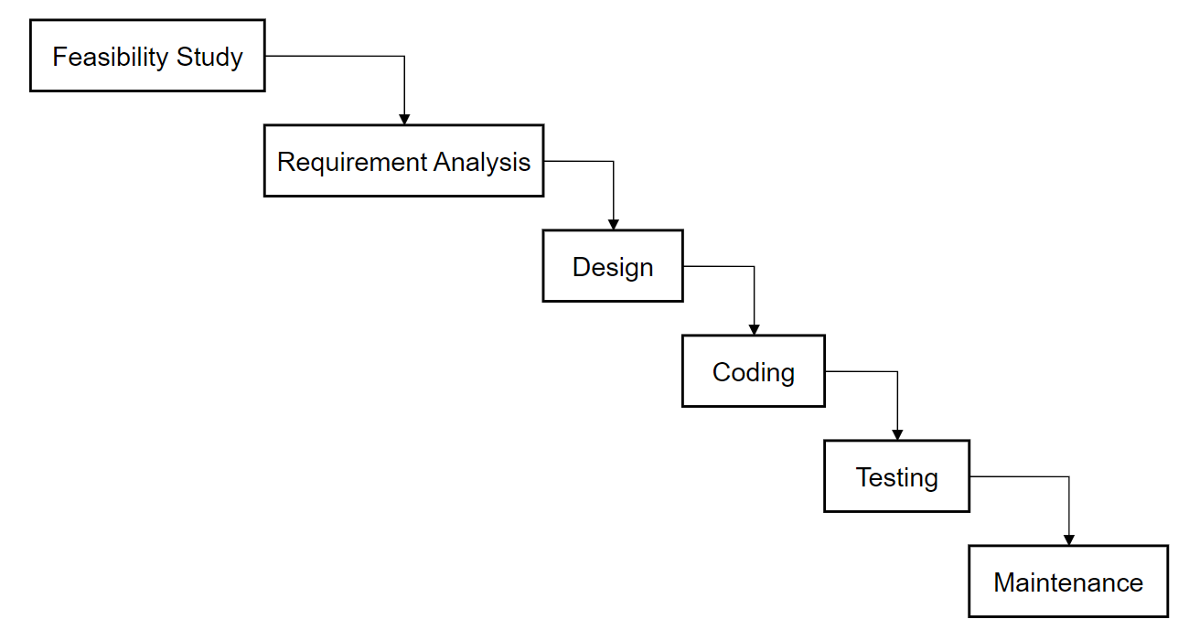

Figure3.1: Waterfall Model

### Requirement Analysis

The requirement analysis is a crucial phase in the development of the

school management system. It identifies and documents the functional and

non-functional requirement necessary for the successful implementation of

system.

#### Functional Requirements

* User authentication and role-based access (Admin, Teacher, Student)
* Student management (add, update, view, and delete student records)
* Teacher management and assignment of subjects and classes
* Class, section, subject, and grade management
* Attendance management for students
* Examination and result management
* Academic year and semester management

**Use Case Diagram**

A use case diagram is a graphical representation used in software engineering to illustrate the interactions between users (actors) and a system. It captures the functional requirements of a system, showing how different users engage with various functionalities within the system.

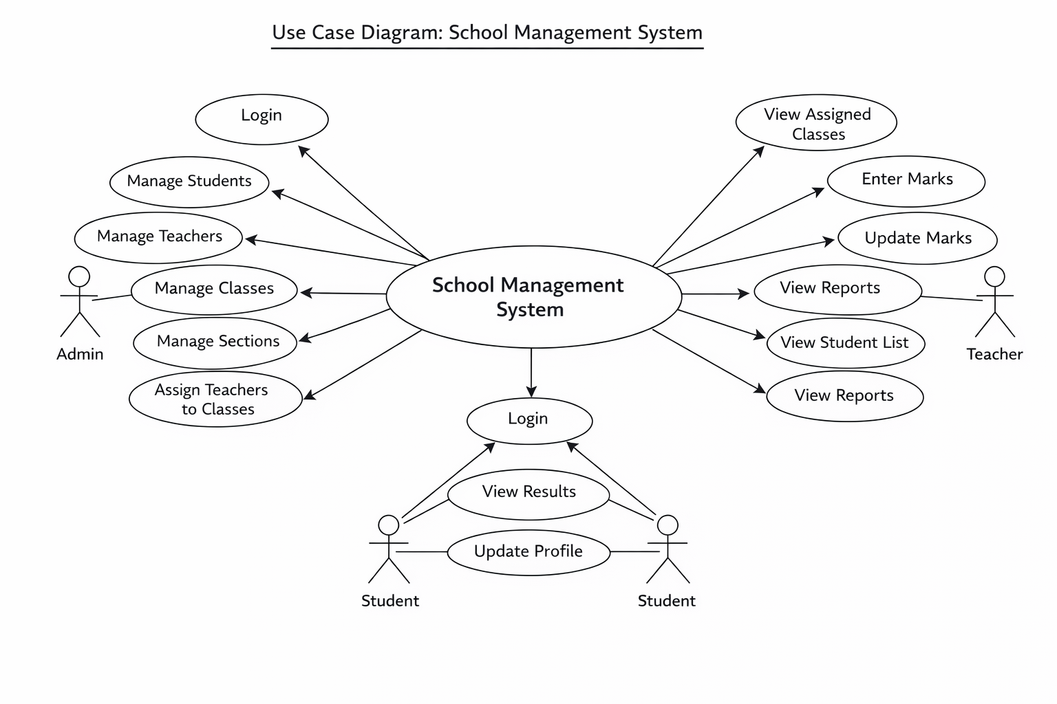

Figure Supervisor’s recommendation.1.1.1: Use Case Diagram

#### Non-Functional Requirements

Non-Functional Requirements describe the general properties of a system. They are among the most important things to define when building the specification for code snippet saving platform, as most have a direct impact on the experience and satisfaction of your users.

Here are some basic types of nonfunctional requirements:

* **Security:** It should be secure, allowing only the authorized users to access and manage their snippets.
* **Usability:** The user interface should beminimal and intuitive, allowing users to easily navigate to different components of the application.
* **Responsiveness**: The app should be fully functional on both desktop and mobile devices.
* **Performance**: The application should have fast response time.

### Feasibility Analysis

#### Technical Feasibility

The required technology stack (i.e., web technologies, database systems) is readily available and well-supported.

#### Operational Feasibility

Skills, time management, and maintenance plans are feasible, with strategies in place for user adoption.

#### Economic Feasibility

The web app does not require extra software and hardware i.e. it uses free and open-source technologies. So, there is no recurring cost than just the internet connection.

#### Schedule

This includes the project schedule, and all the time allocated for its completion. The Gantt chart is as follow:

Figure System Analysis and Design.1.2.4: Gantt Chart

### Data Modelling (ER-diagram)

Data models define how data is connected to each other and how they are processed and stored in a system. There are different data models which are used to design and develop the database, but here we use ER (Entity Relationship) Model.

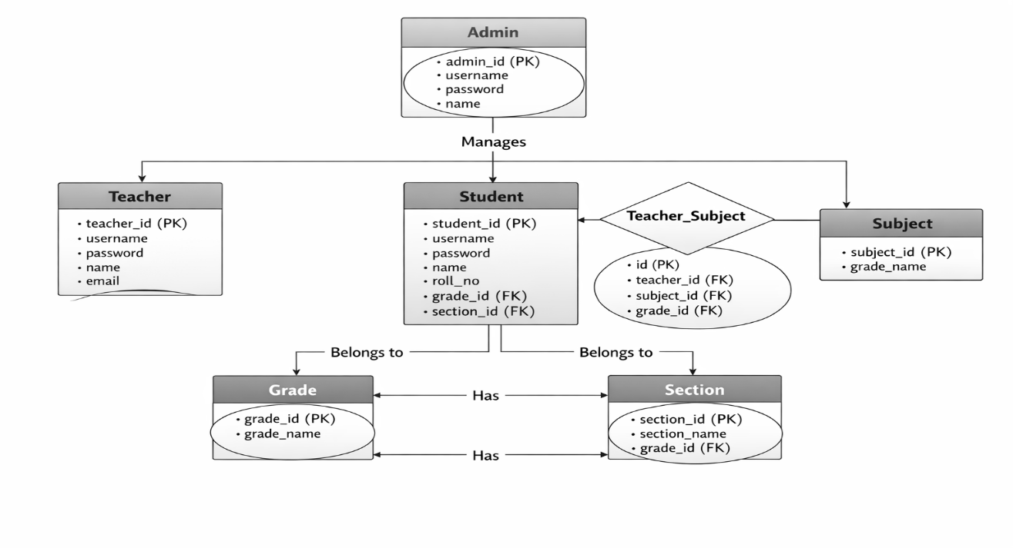

Figure System Analysis and Design.1.3: ER Diagram

The above ER diagram represents a car rental portal with six main entities.

* **ADMIN:** Represents the school administrators who manage the system, with attributes like **ADMIN_ID** (unique administrator identifier), **NAME** (administrator name), **EMAIL** (administrator email address), and **PASSWORD** (administrator login password).
* STUDENT: Represents the students of the school, with attributes like STUDENT_ID (unique student identifier), NAME (student name), CLASS (class enrolled in), SECTION (section of the class), and CONTACT (student contact details).
* TEACHER: Represents the teachers of the school, with attributes like TEACHER_ID (unique teacher identifier), NAME (teacher name), SUBJECT (subject handled by the teacher), and CONTACT (teacher contact details).
* CLASS: Represents the classes in the school, with attributes like CLASS_ID (unique class identifier), CLASS_NAME (name of the class), and ROOM_NO (classroom number).
* SUBJECT: Represents the subjects offered by the school, with attributes like SUBJECT_ID (unique subject identifier) and SUBJECT_NAME (name of the subject).
* RESULT: Represents the examination results of students, with attributes like RESULT_ID (unique result identifier), MARKS (marks obtained by the student), and GRADE (grade awarded).

### Process Modeling (DFD)

Process Modeling with DFDs visually represents data flow in a system, showing processes, data stores, and external entities. Level 0 gives a high-level overview, Level 1 breaks it into major processes, and Level 2 details each process. They help understand, design, and document systems effectively.

**Level 0 DFD (Context Diagram)** provides a high-level overview of the system, showing the **User** interacting with the **System**to submit, search, and receive results, without detailing internal processes.

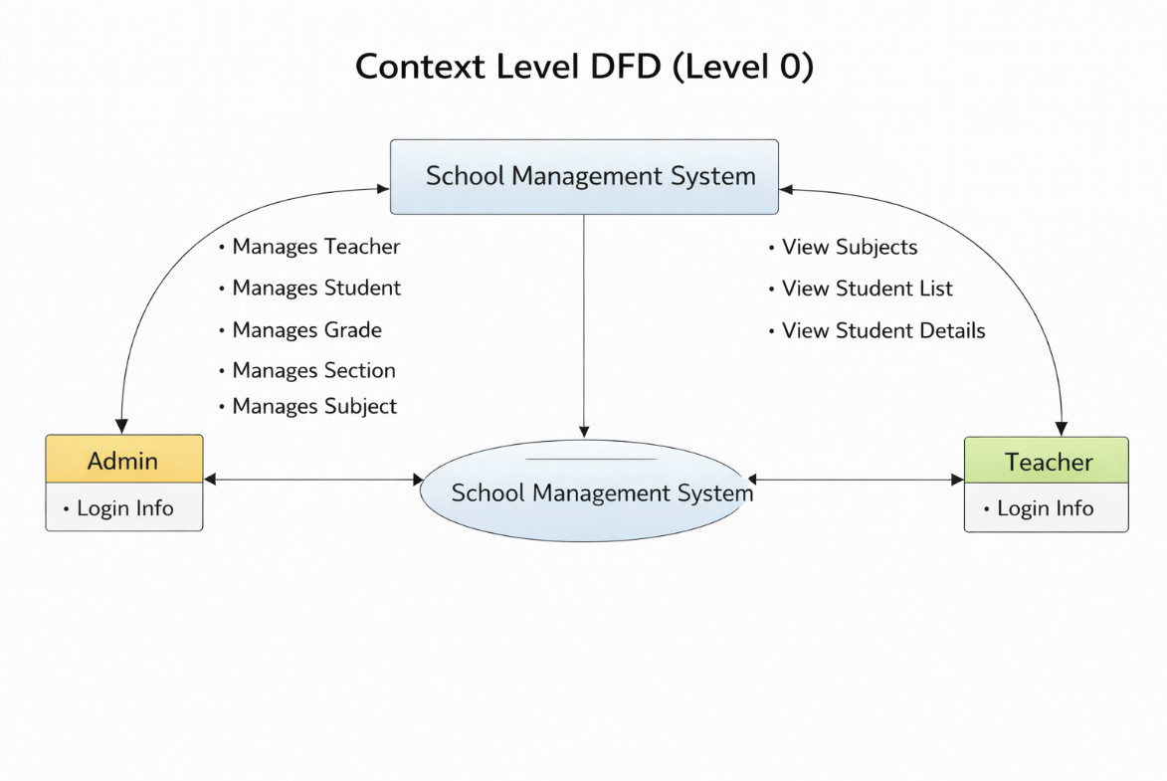

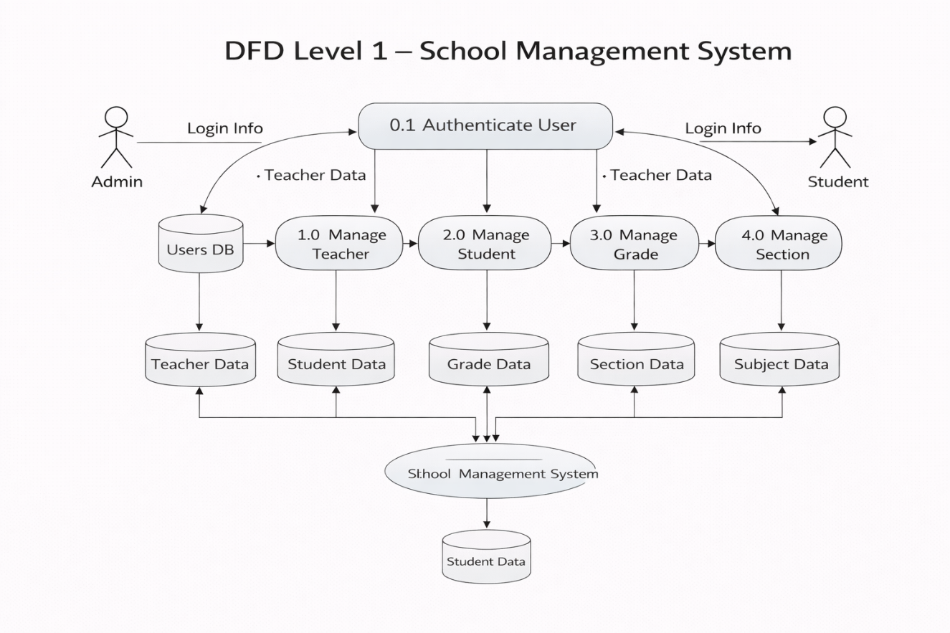

Figure System Analysis and Design.1.4.2: Level 1 DFD

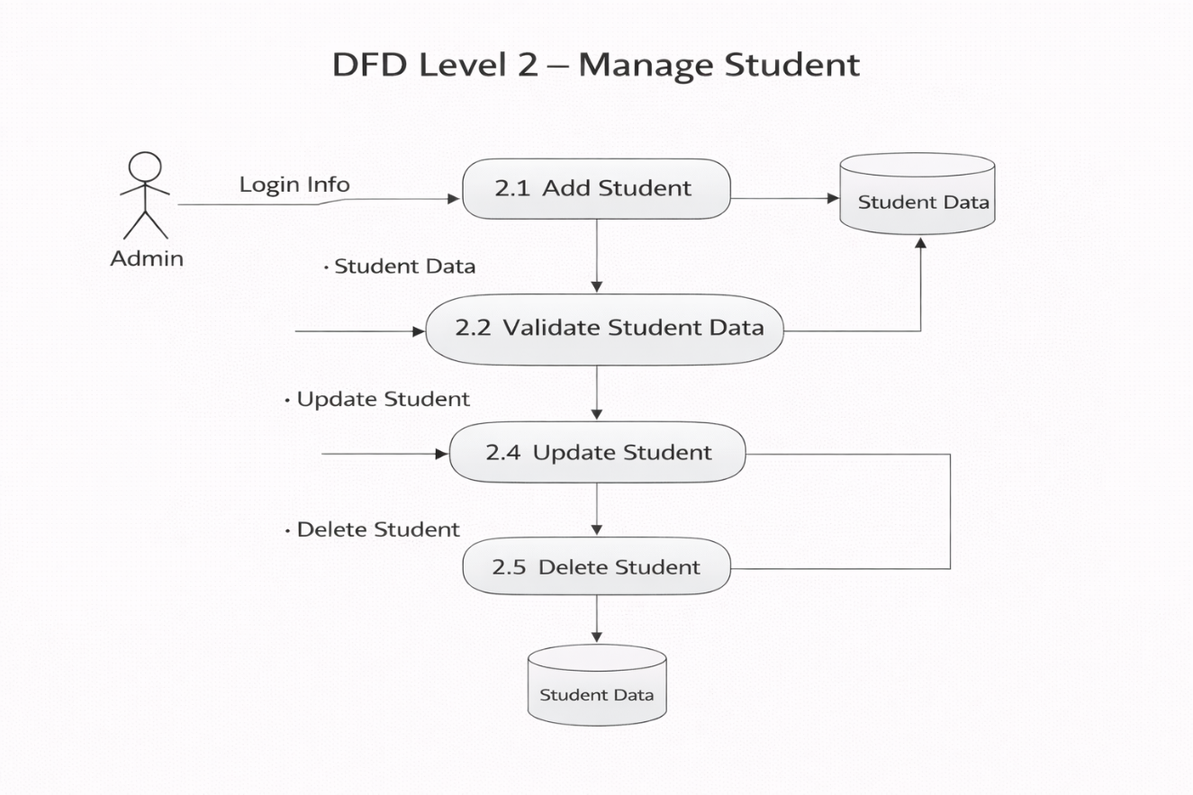

Figure System Analysis and Design.1.4.3: Level 2 DFD

## System Design

### **Architectural Design**

Figure System Analysis and Design.2.1: Architectural Design

### Database Schema Design

The design of the database is called a schema. This tells us about the structural view of the database. It gives us an overall description of the database. A database schema defines how the data is organized using the schema diagram. A schema diagram is a diagram which contains entities and the attributes that will define that schema. A schema diagram only shows us the database design. It does not show the actual data of the database. A Schema can be a single table, or it can have more than one table which is related. The schema represents the relationship between these tables.

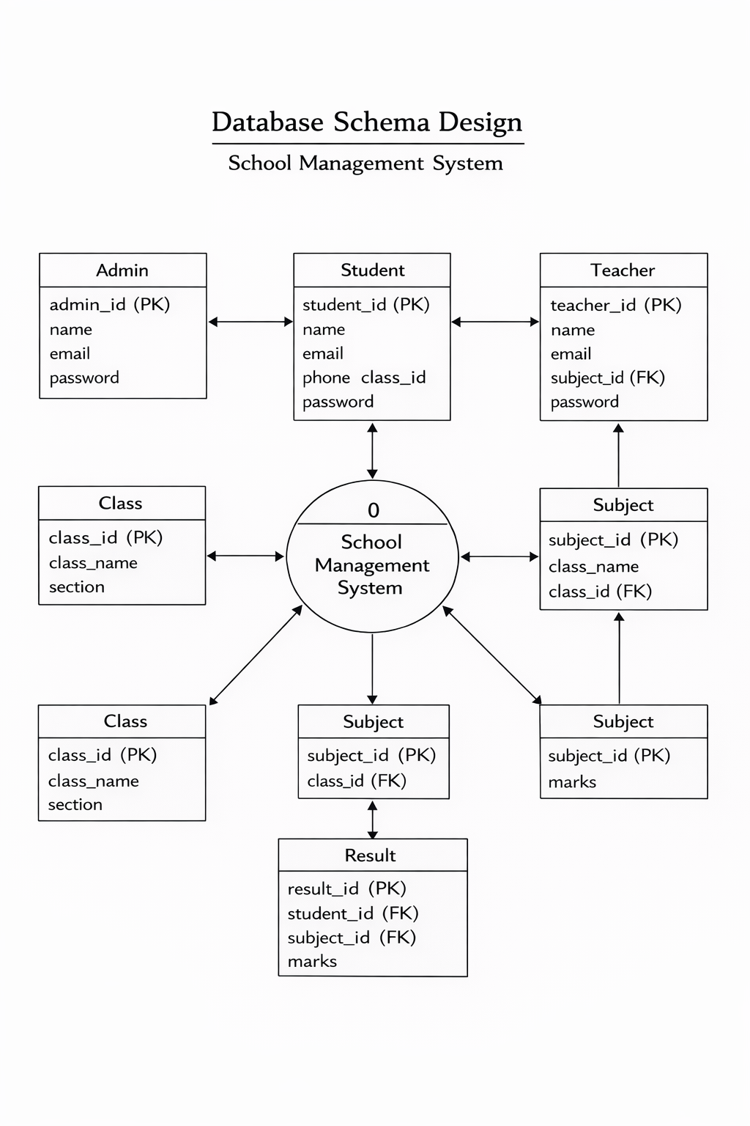

Figure System Analysis and Design.2.2: Database Schema Design

### Interface Design

The interface design of the system focuses on providing a simple and user-friendly experience for all users. The target users include Admin, Teachers, and Students who can easily manage academic information through the system. The system is developed using PHP, CSS, JavaScript, HTML, Bootstrap, and MySQL to ensure smooth functionality, responsiveness, and reliability.



Figure System Analysis and Design.2.3.1: Home Page

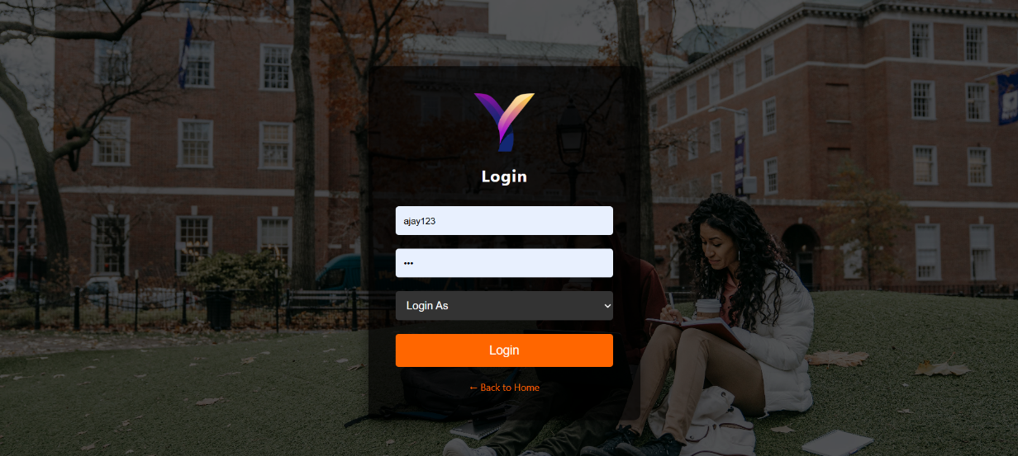

Figure System Analysis and Design.2.3.3: Login Page

### Physical DFD

A **Physical DFD** shows how data flows in a system, focusing on the physical implementation, such as hardware, software, databases, and user interactions. It emphasizes the how and where of data processing, unlike a logical DFD that focuses on the what.

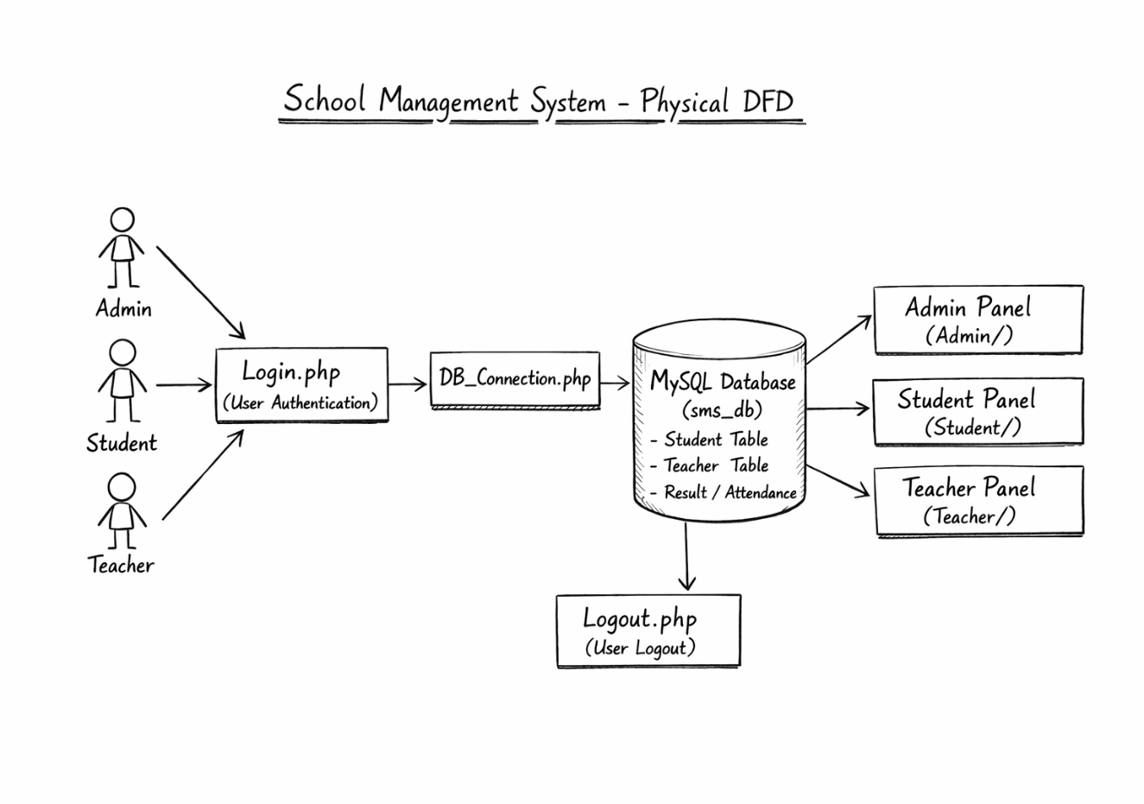

Figure System Analysis and Design.2.4: Physical DFD

# Implementation & Testing

## Implementation

In this phase, the theoretical design is transformed into a functional system. With the design phase complete, the focus now shifts to technical implementation. This involves coding the application based on the system's requirements and specifications.

### Tools Used

#### Programming Languages

* **PHP**: Used for developing the backend with MySQL.
* **JavaScript**: Used for building and logic in frontend
* **HTML , CSS & Bootstrap**: Used for structuring and styling the frontend.

#### Database Platforms

* **MySQL**: Serves as the primary database for storing students data, teacher’s data and related information.

### Implementation Details of Modules

#### Login Module:

* + - For login, users will enter their username/email and password.
    - Admin, Teacher, and Student credentials are verified from the database.
    - After successful login, users are redirected to their respective dashboards.
    - Invalid login details will show an error message.

#### Admin Module:

* + - Admin can add, update, view, anddelete students and teachers.
    - Admin can manage classes, sections, and subjects.
    - Admin assigns subjects and classes to teachers.

#### Teacher Module:

* + - Teachers can view their assigned classes and subjects.
    - Teachers can add and update student marks/grades.
    - Teachers can view the student list of assigned classes.

#### Student Module:

* + - Students can view their profile details.
    - Students can check their marks and grades.

#### Logout Module:

* + - Users can logout from the system securely.
    - User is redirected to the login page.

## Testing

Testing is a process of executing a program with the intent of finding an error. A good test case is one that has a high probability of finding an undiscovered error. The primary objective for test case design is to derive a set of tests that has the highest livelihood for uncovering defects in software. To accomplish this objective two different categories of test case design are used.

### Test Cases for Unit Testing

Unit Test focuses on verifying the correctness of individual components or units of code, such as a single function, method, or class. They are performed early in the development process to catch bugs at the foundational level and provide developers with immediate feedback on their code.

Table 4.2.1.1: Test Case for Login

|  |  |  |  |  |  |
| --- | --- | --- | --- | --- | --- |
| Test cases no | Test Case | Input data | Expected results | Status |  |
| 1 | Logging into website | Valid username and password | User logged in successfully | Pass |  |
| 2 | Logging into website | Valid username, wrong password | Error message displayed | pass |  |
| 3 | Logging into website | Empty username password | Validation message shown | pass |  |

|  |  |  |  |  |
| --- | --- | --- | --- | --- |
| Test cases no | Test Case | Input data | Expected results | Status |
| 1 | Add new student | Valid student details | Student added successfully | Pass |
| 2 | Update teacher details | Modified teacher data | Data updated in database | Pass |
| 3 | Delete class record | Valid class id | Class deleted successfully | Pass |

Table 4.2.1.3: Test Cases for Admin Module

Table 4.2.1.4: Test Cases for Teacher Module

|  |  |  |  |  |
| --- | --- | --- | --- | --- |
| Test case id | Test case | Input data | Expected result | Status |
| 1 | View assigned classes | Teacher login | Assigned classes displayed | Pass |
| 2 | Enter student marks | Valid marks data | Marks saved successfully | Pass |
| 3 | Unauthorized access | Other class denied | Access denied | Pass |

Table 4.2.1.4: Test Cases for Student Module

|  |  |  |  |  |
| --- | --- | --- | --- | --- |
| Test case id | Test case | Input data | Expected result | Status |
| 1 | Student login | Valid credentials | Login successful | Pass |
| 2 | View marks | Student ID | Marks displayed | Pass |
| 3 | Edit marks attempt | Modify request | Access denied | Pass |

### Test Cases for System Testing

System Test evaluates the entire system or application, including all integrated components and interactions. They are performed after integration and unit testing to confirm that the complete system works seamlessly and delivers the expected user experience.

Table 4.2.2: System Test Cases

|  |  |  |  |  |
| --- | --- | --- | --- | --- |
| Test Case No | Test Case | Input Data | Expected Outcome | Result |
| 1 | System load with valid login | Valid user credentials | System load dashboard successfully | Pass |
| 2 | Role-based access control | Admin/teacher/student login | User redirected to correct module | Pass |
| 3 | Database connectivity | System request | Data fetched without error | Pass |
| 4 | Unauthorized Page access | Direct URL access | Access denied/ redirect to login page | Pass |
| 5 | Data consistency check | Add / update records | Data correctly stored in database | Pass |
| 6 | Session handling | User inactivity / logout | Session expires | Pass |
| 7 | System logout | Logout request | User logout successfully | Pass |
| 8 | Error handling | Invalid input | Proper message displayed | Pass |
| 9 | Overall system workflow | Complete system usage | System works as per requirement | Pass |

# Conclusion and Future Recommendations

## Lesson Learnt

During the development of this School Management System, valuable lessons related to full-stack web development were learned, starting from system planning to implementation. The backend was developed using PHP and MySQL, which improved understanding of user authentication, CRUD operations, and database relationship management between students, teachers, classes, subjects, and results.

Working on different modules such as student management, teacher management, subject allocation, and result handling helped in understanding how data flows between the frontend and backend and how user actions are processed securely.

On the frontend, HTML and CSS were used to design a simple and user-friendly interface. This improved skills in structuring web pages and maintaining consistency across different modules of the system.

## Conclusion

The School Management System is designed to help schools manage their daily administrative tasks efficiently. This application collects student, teacher, and class information through an online platform, enabling administrators to access and update records conveniently. It provides a centralized system where users can manage student enrollment, teacher assignments, and class schedules.

The project was developed to simplify school management at various levels. In the current manual system, maintaining records and managing classes is time-consuming and prone to errors, making the overall process inefficient.

The main goal of this project is to automate school management tasks, such as storing student and teacher information, managing classes and sections, and maintaining overall school records. It is a comprehensive system that streamlines daily operations for school administrators, allowing them to store and access information digitally at any time. Overall, this system is an innovative and efficient solution for managing school operation.Top of Form

Bottom of Form

## Future Recommendations

While the project successfully fulfills its primary objectives, there are some areas where further improvements can be made in future versions. The following recommendations are suggested:

* **Limited Language Support:**

The current system supports limited language options. In the future, multi-language support can be added to make the system more user-friendly.

* **Profile Update Limitation:**

Users cannot update their profile details after registration. A profile update feature can be introduced to allow users to modify their information when needed.

* **Single Admin Role:**

The system supports only one admin role. Future enhancement can include multiple admin roles with role-based access control.

* **Security and Notification Features:**

Advanced security features and notification systems can be added to improve data safety and user communication.

# Appendices

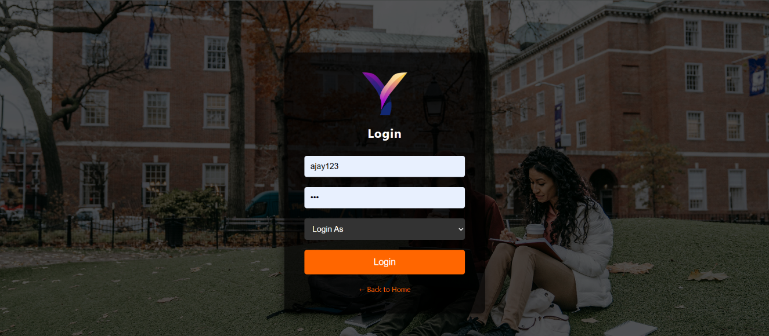

Figure i: Login Page





Figure iii: Home Page/ Index Page

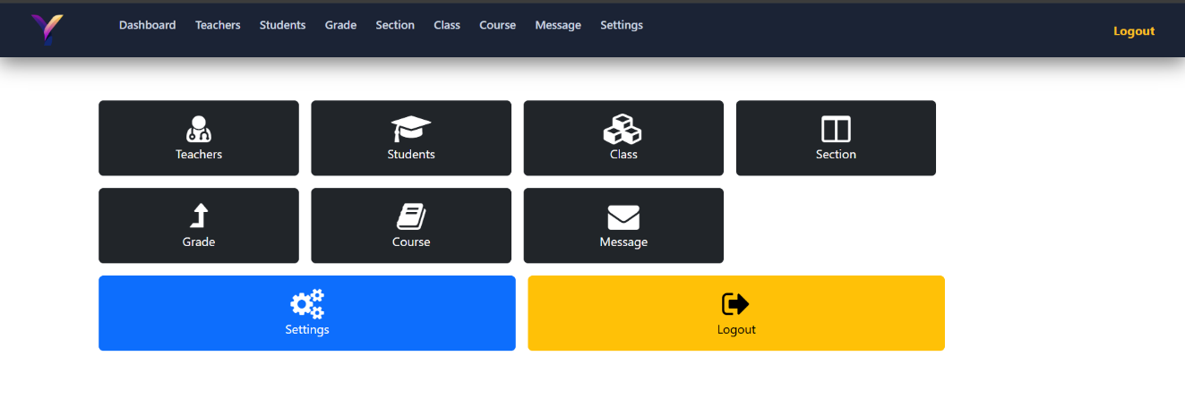

Figure iv: Admin dashboard

# References ­

* W3Schools. (2025). *PHP Tutorial*. Retrieved from <https://www.w3schools.com/php/>
* W3Schools. (2025). *MySQL Tutorial*. Retrieved from <https://www.w3schools.com/sql/>
* Bootstrap 5 Documentation. (2025). Retrieved from <https://getbootstrap.com/docs/5.0/getting-started/introduction/>
* MDN Web Docs. (2025). *HTML & CSS Reference*. Retrieved from <https://developer.mozilla.org/>
* Kumar, A., & Sharma, R. (2022). *Web-Based School Management Systems*. International Journal of IT Research.